Test Case: tc002_SPX_Dev5_Crear_Requisicion_Spot_Tipo_Cobro_Project
Step 1 - Enter username and password and click to button Enter: Credentials Entered
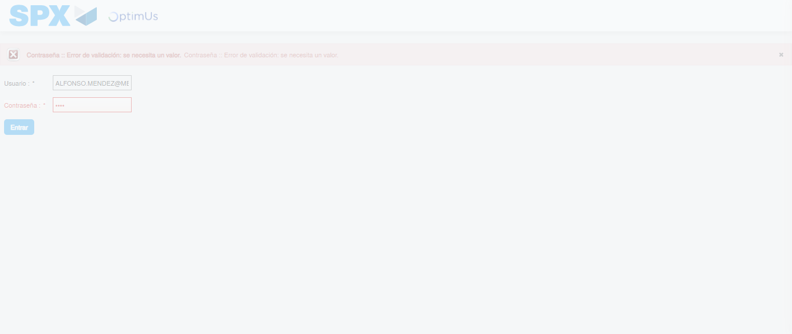Image file-name: QC_Testing-tc002_SPX_Dev5_Crear_Requisicion_Spot_Tipo_Cobro_Project-1783381398865

Step 2 - Select to UEN and Access to Spot Buy Requisitions : UEN Correctly selected and Correct access
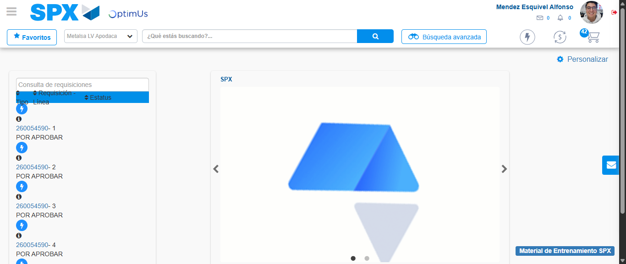Image file-name: QC_Testing-tc002_SPX_Dev5_Crear_Requisicion_Spot_Tipo_Cobro_Project-1783381486815

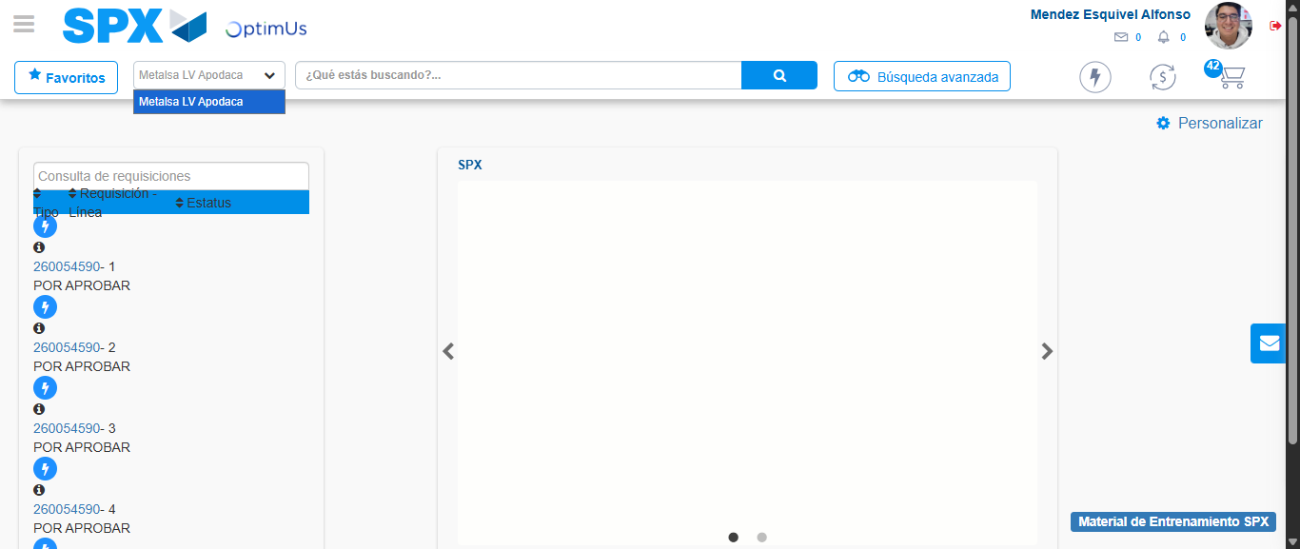Image file-name: QC_Testing-tc002_SPX_Dev5_Crear_Requisicion_Spot_Tipo_Cobro_Project-1783381489432

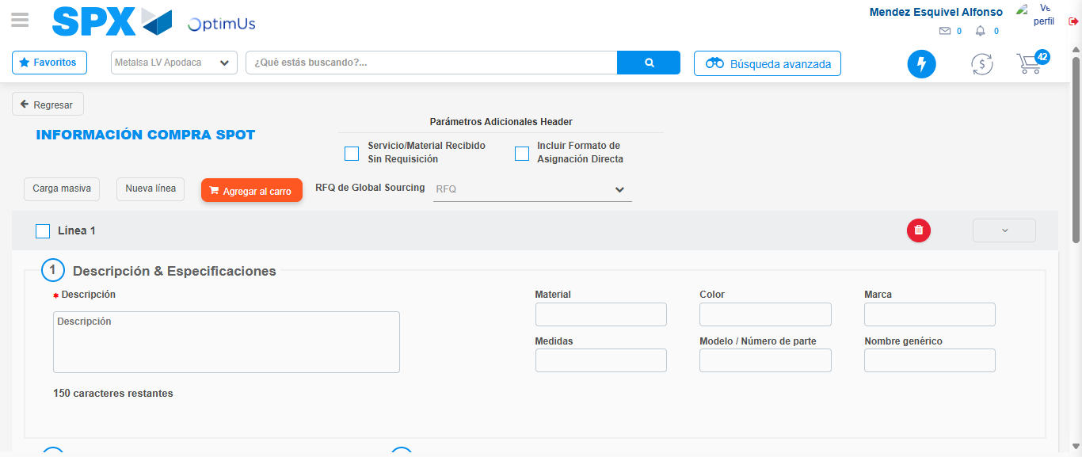Image file-name: QC_Testing-tc002_SPX_Dev5_Crear_Requisicion_Spot_Tipo_Cobro_Project-1783381495423

Step 3 - Data Capture Spot Buy Requisition: Data captured correctly
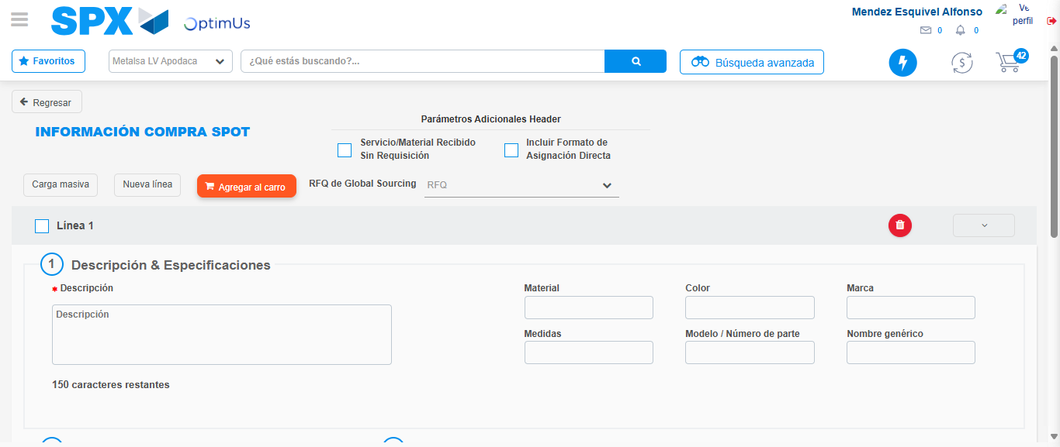Image file-name: QC_Testing-tc002_SPX_Dev5_Crear_Requisicion_Spot_Tipo_Cobro_Project-1783381495658

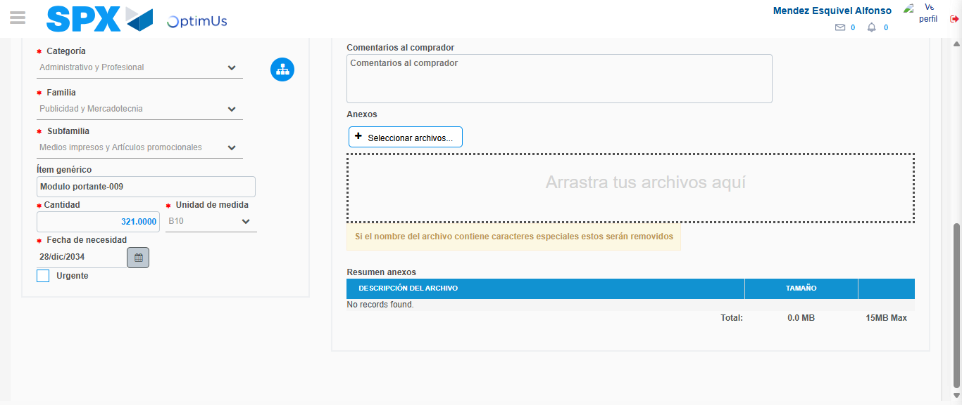Image file-name: QC_Testing-tc002_SPX_Dev5_Crear_Requisicion_Spot_Tipo_Cobro_Project-1783381505067

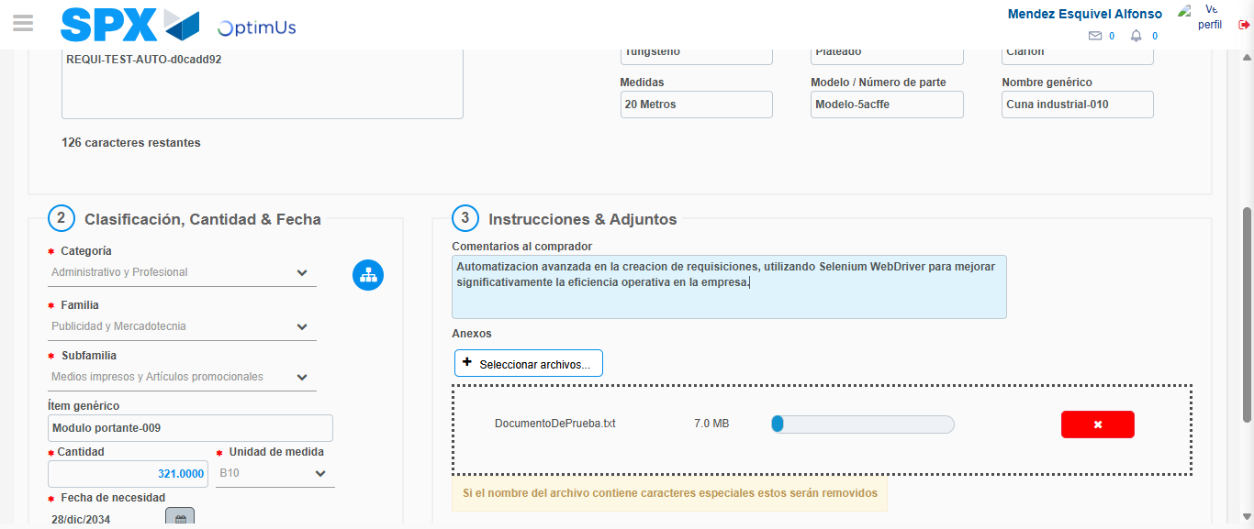Image file-name: QC_Testing-tc002_SPX_Dev5_Crear_Requisicion_Spot_Tipo_Cobro_Project-1783381505841

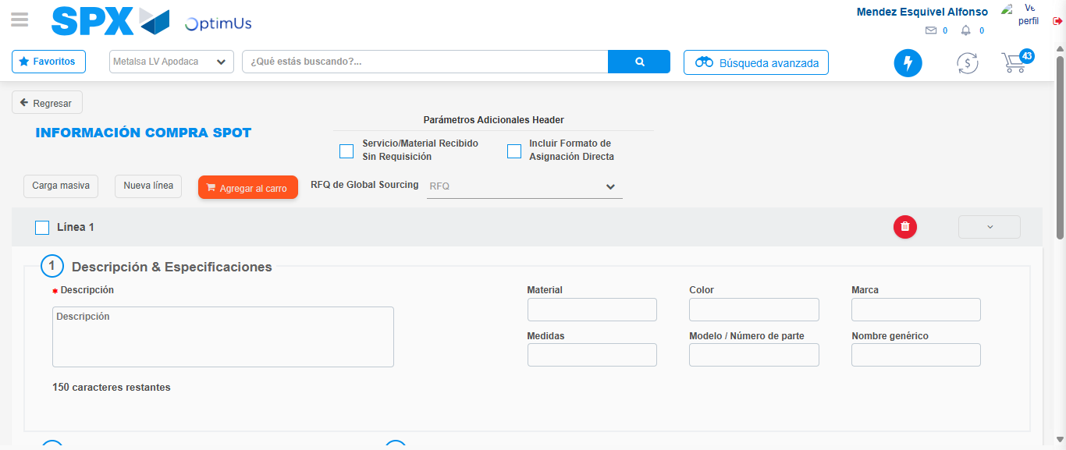Image file-name: QC_Testing-tc002_SPX_Dev5_Crear_Requisicion_Spot_Tipo_Cobro_Project-1783381507764

Step 7 - Return to Main Page SPX : Return to Main Page SPX
Image file-name: QC_Testing-tc002_SPX_Dev5_Crear_Requisicion_Spot_Tipo_Cobro_Project-1783381486815

Image file-name: QC_Testing-tc002_SPX_Dev5_Crear_Requisicion_Spot_Tipo_Cobro_Project-1783381489432

Image file-name: QC_Testing-tc002_SPX_Dev5_Crear_Requisicion_Spot_Tipo_Cobro_Project-1783381495423

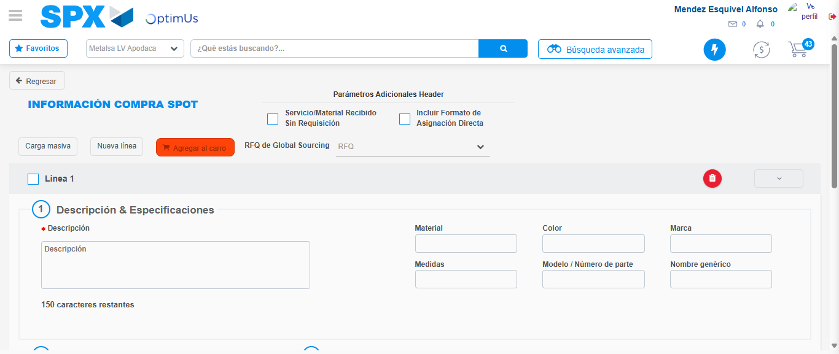Image file-name: QC_Testing-tc002_SPX_Dev5_Crear_Requisicion_Spot_Tipo_Cobro_Project-1783381509965

Image file-name: QC_Testing-tc002_SPX_Dev5_Crear_Requisicion_Spot_Tipo_Cobro_Project-1783381510139

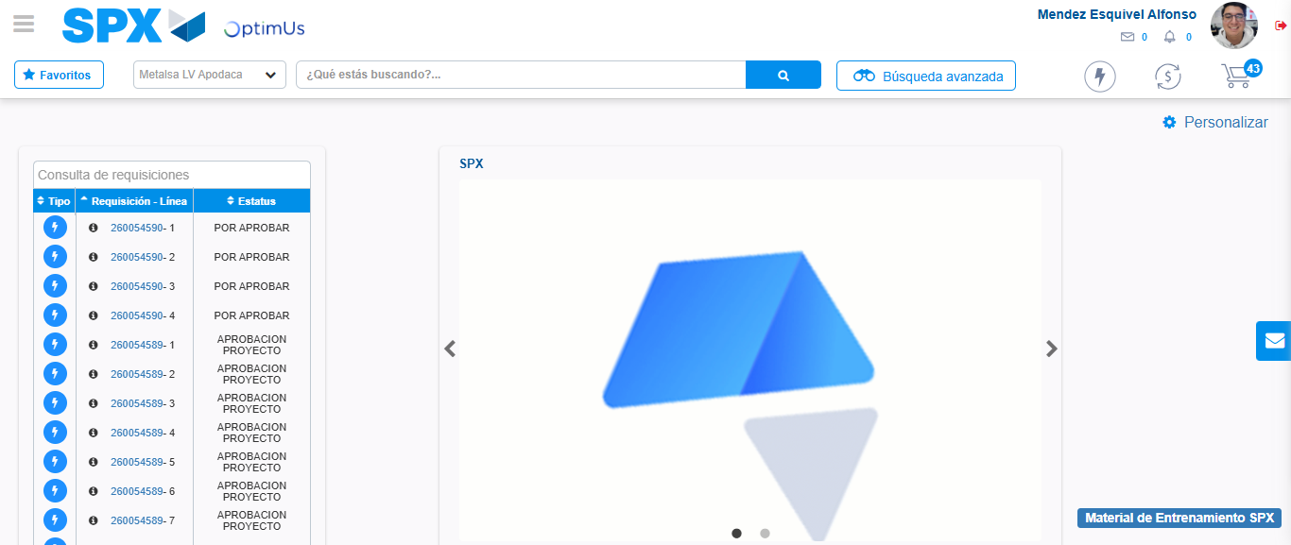Image file-name: QC_Testing-tc002_SPX_Dev5_Crear_Requisicion_Spot_Tipo_Cobro_Project-1783381531822

Step 8 - Log Out : Log Out SPX
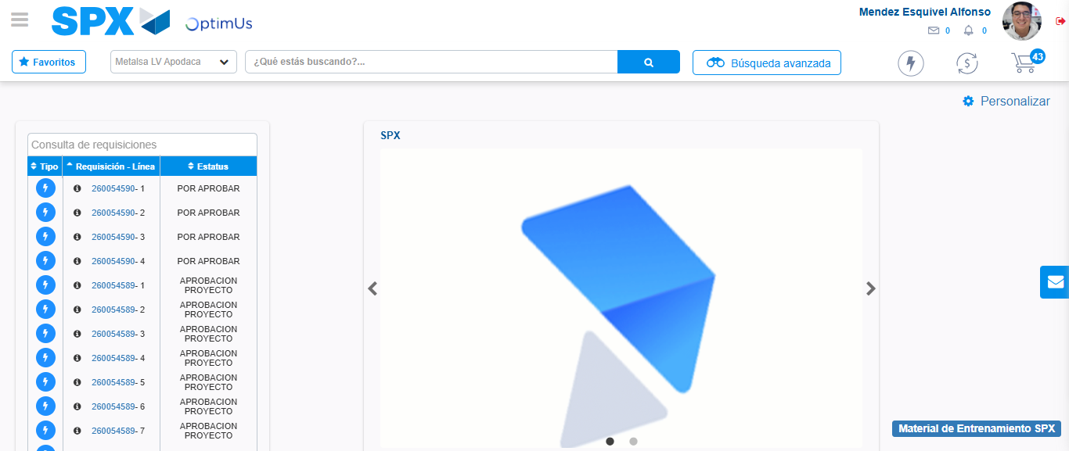Image file-name: QC_Testing-tc002_SPX_Dev5_Crear_Requisicion_Spot_Tipo_Cobro_Project-1783381532087

